Shrinkage correlation: AUDUSD and USDCHF
Method 08 / eight-major panel / delta = 0.2 and Ledoit-Wolf / Alpari D1 full available history

Study setup
Logical pair: AUDUSD , USDCHF
Broker symbols: AUDUSD_i , USDCHF_i
Snapshot: 2026-11-03_majors_alpari_D1
Timeframe: D1
Common eight-major panel window: 1999-01-06 to 2026-11-02 (UTC bar dates)
Panel matched return count n: 7127
Dropped unfinished last bar dated 2026-11-03 UTC after a tick-volume check against the prior complete day.
Fixed shrinkage: delta=0.2, mu=3.9170889e-05 (mean of diag(S))
Ledoit-Wolf estimated delta: 0.0042157642
Panel symbols: EURUSD, GBPUSD, AUDUSD, NZDUSD, USDJPY, USDCHF, USDCAD, EURGBP
Complete matched rows (Excel): AUDUSD-USDCHF_Shrinkage_D1.xlsx
Complete matched rows (HTML table): AUDUSD-USDCHF_Shrinkage_D1_data.html

Method carried forward
Shrinkage blends the sample covariance matrix S of matched daily log returns of close, ln(close_t / close_t-1), toward a simple target, then converts the shrunk covariance into correlations. Quotes are not inverted. This experiment builds one common calendar across all eight majors, forms S with the unbiased n-1 divisor, then reports two shrinkage specs: fixed delta = 0.2 with mu equal to the average sample variance (mu * I target), and sklearn Ledoit-Wolf with its estimated delta. Pair reports pull rho_ij from those panel matrices. Same-panel Pearson r is a side check only. Shrinkage improves conditioning; it is not a cause, not a lead, and not a trading signal.

Results
pearson_r | rho_02 | rho_LW | rho_02_minus_r | rho_LW_minus_r | delta_LW
-0.381088 | -0.318051 | -0.379811 | 0.063037 | 0.001277 | 0.00421576

Conclusion
Over the common 7127-day eight-major panel for AUDUSD and USDCHF (broker quote directions unchanged), fixed-delta shrinkage correlation at delta=0.2 is -0.3181 (negative, weak linear link in this sample). Ledoit-Wolf rho is -0.3798 with estimated delta=0.004216. Same-panel Pearson r is -0.3811 (rho_02 minus r = 0.0630; rho_LW minus r = 0.0013). This does not establish cause, lead-lag, or a lasting trading rule.

Charts
Daily closes
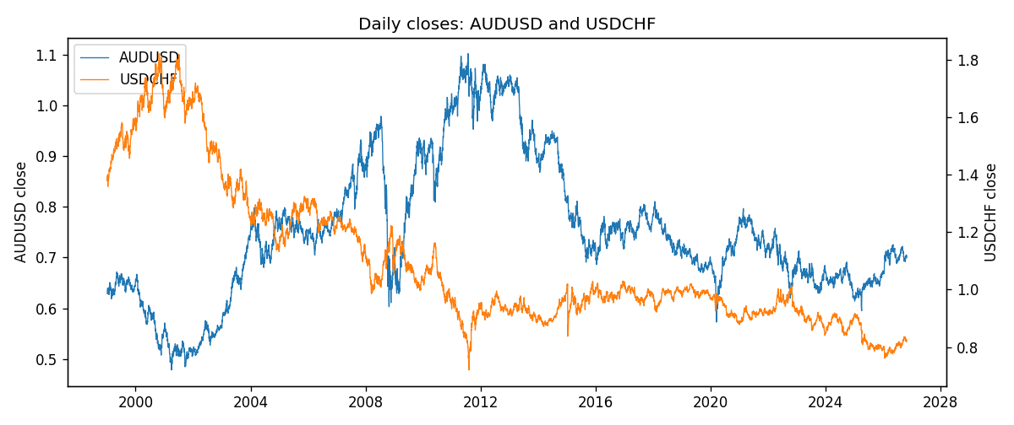
Daily log returns
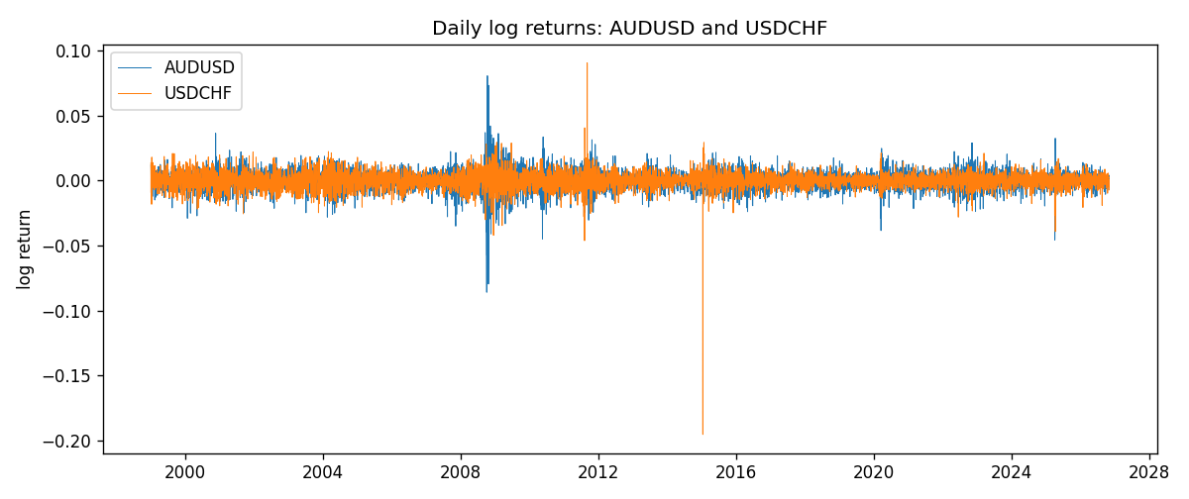
Log-return scatter
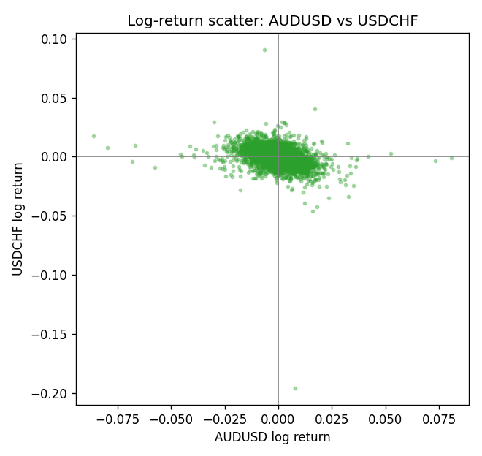

Data report
Every panel row for this pair slice is stored in the sibling Excel workbook named AUDUSD-USDCHF_Shrinkage_D1.xlsx. Full-panel covariance and correlation matrices are saved once under outputs/ as CSV files. Embedding all rows as a Word table is impractical at this length; the Word file holds the column list, column summaries, and the first and last 15 matched rows.
Columns: time, AUDUSD_open, AUDUSD_high, AUDUSD_low, AUDUSD_close, AUDUSD_tick_volume, AUDUSD_spread, AUDUSD_real_volume, AUDUSD_log_return, USDCHF_open, USDCHF_high, USDCHF_low, USDCHF_close, USDCHF_tick_volume, USDCHF_spread, USDCHF_real_volume, USDCHF_log_return
Column summaries (panel rows)
column | count | mean | std | min | 25% | 50% | 75% | max
AUDUSD_open | 7127 | 0.75283275 | 0.13531386 | 0.4785 | 0.66158 | 0.7319 | 0.812805 | 1.10284
AUDUSD_high | 7127 | 0.75689359 | 0.13587198 | 0.4878 | 0.66567 | 0.73555 | 0.8193 | 1.10795
AUDUSD_low | 7127 | 0.74877471 | 0.1346251 | 0.4775 | 0.65837 | 0.72811 | 0.80713 | 1.0975
AUDUSD_close | 7127 | 0.75288849 | 0.13529323 | 0.4786 | 0.661725 | 0.7321 | 0.812865 | 1.10169
AUDUSD_tick_volume | 7127 | 78106.737 | 138648.75 | 109 | 5647 | 44017 | 71744.5 | 1234623
AUDUSD_spread | 7127 | 30.658622 | 16.888951 | 0 | 13 | 30 | 50 | 50
AUDUSD_real_volume | 7127 | 5.2965195e+09 | 1.2602867e+11 | 0 | 0 | 0 | 0 | 3.811512e+12
AUDUSD_log_return | 7127 | 3.23e-05 | 0.0075548 | -0.08602525 | -0.00385041 | 0.00029027 | 0.00415332 | 0.0806166
USDCHF_open | 7127 | 1.0950724 | 0.25120393 | 0.72022 | 0.92018 | 0.98921 | 1.23375 | 1.8219
USDCHF_high | 7127 | 1.1003422 | 0.25292835 | 0.73305 | 0.924355 | 0.99265 | 1.2388 | 1.8313
USDCHF_low | 7127 | 1.0899719 | 0.24962782 | 0.08565 | 0.91675 | 0.98562 | 1.22815 | 1.8121
USDCHF_close | 7127 | 1.0950652 | 0.25109829 | 0.72025 | 0.92039 | 0.98915 | 1.23375 | 1.8217
USDCHF_tick_volume | 7127 | 74858.54 | 113805.19 | 350 | 12933.5 | 40528 | 70784 | 858589
USDCHF_spread | 7127 | 25.804827 | 24.609722 | 0 | 5 | 16 | 50 | 100
USDCHF_real_volume | 7127 | 2.3477824e+10 | 8.9470976e+10 | 0 | 0 | 0 | 0 | 1.9331921e+12
USDCHF_log_return | 7127 | -7.023e-05 | 0.006591 | -0.19545699 | -0.00334576 | 8.055e-05 | 0.00331687 | 0.09051364
First 15 panel rows (selected columns)
time | AUDUSD_close | USDCHF_close | AUDUSD_log_return | USDCHF_log_return
1999-01-06 | 0.6289 | 1.3912 | 0.011836351 | 0.013605652
1999-01-07 | 0.6345 | 1.3782 | 0.0088650256 | -0.0093883841
1999-01-08 | 0.6347 | 1.3935 | 0.00031515916 | 0.011040268
1999-01-11 | 0.6393 | 1.4009 | 0.0072213815 | 0.0052963193
1999-01-12 | 0.6362 | 1.3872 | -0.0048608485 | -0.0098275602
1999-01-13 | 0.6312 | 1.3621 | -0.0078902098 | -0.018259701
1999-01-14 | 0.6295 | 1.3588 | -0.002696916 | -0.0024256692
1999-01-15 | 0.634 | 1.3834 | 0.007123101 | 0.01794228
1999-01-18 | 0.6346 | 1.379 | 0.00094592471 | -0.0031856384
1999-01-19 | 0.6392 | 1.3789 | 0.0072225153 | -7.2518946e-05
1999-01-20 | 0.64 | 1.3889 | 0.0012507819 | 0.0072259871
1999-01-21 | 0.6405 | 1.3836 | 0.00078094498 | -0.0038232689
1999-01-22 | 0.6327 | 1.3834 | -0.012252745 | -0.0001445609
1999-01-25 | 0.6302 | 1.3868 | -0.0039591468 | 0.0024546976
1999-01-26 | 0.6305 | 1.3897 | 0.00047592608 | 0.0020889617
Last 15 panel rows (selected columns)
time | AUDUSD_close | USDCHF_close | AUDUSD_log_return | USDCHF_log_return
2026-10-13 | 0.69821 | 0.83244 | 0.0035007712 | -0.0024955621
2026-10-14 | 0.69715 | 0.83489 | -0.0015193215 | 0.0029388325
2026-10-15 | 0.69191 | 0.82676 | -0.0075447063 | -0.0097855323
2026-10-16 | 0.69426 | 0.82377 | 0.0033906408 | -0.0036230826
2026-10-19 | 0.6978 | 0.82677 | 0.0050859986 | 0.0036351779
2026-10-20 | 0.70022 | 0.8246 | 0.0034620426 | -0.0026281224
2026-10-21 | 0.70275 | 0.82427 | 0.0036066384 | -0.00040027413
2026-10-22 | 0.70186 | 0.82032 | -0.0012672558 | -0.0048036381
2026-10-23 | 0.70353 | 0.82497 | 0.0023765656 | 0.005652514
2026-10-26 | 0.70128 | 0.82649 | -0.0032032829 | 0.0018407959
2026-10-27 | 0.70245 | 0.82865 | 0.0016669876 | 0.0026100526
2026-10-28 | 0.70533 | 0.82781 | 0.0040915541 | -0.0010142111
2026-10-29 | 0.70245 | 0.82379 | -0.0040915541 | -0.0048680164
2026-10-30 | 0.70316 | 0.82438 | 0.0010102376 | 0.00071594559
2026-11-02 | 0.69971 | 0.81851 | -0.0049184984 | -0.0071459744

